Project 2: *Does Legislation Improve Dental Health and Youth Tobacco Usage?*

Allison MacDonald

Data Science Program

Lewis University

Romeoville, IL, USA

allisonnmacdonald@lewisu.edu

I. *Introduction*

Children in any place in the world should be considered the highest priority because of their vulnerability and their inability to understand how to take care of themselves. Because of this fact, state governments around the United States have chosen to write up bills and legislation to help fight obesity, increase nutrition and increase physical activity for their communities. Children affected by these legislation are affected more so than adults as the legislation targets schools and parks. Even with these legislations in place, is there improvement that can be seen in keeping children the healthiest they can be? To determine this, we will be looking at three different datasets. The first set comes from the CDC where they’ve collected information that is related to legislation and regulations passed to focus on nutrition, physical activity and obesity. The next set, also from the CDC, is a survey done to determine the percentage tobacco use in middle school and high school students. Both CDC datasets have data collected from all 50 states and from the year 2001 to 2017. The third data set from the CDC is a state survey that checks for oral health in students in elementary school. This set also has data from all 50 states and spans over the years 1994 to 2019. All datasets were analyzed using Tableau and cleaned to fix any issues with the data entries.

A. *Hypothesis*

The hypothesis for these three datasets is that because there is a high number of nutrition, obesity and physical activity policies being put in place around the U.S., this means that their introduction into communities with improve overall oral health in the survey populations and decrease the rate at which youths choose to use tobacco.

Features of Datasets

Youth Tobacco Survey by CDC

1. Education Status of Students (Middle School/HighSchool)
2. Gender (M/F)
3. Percent of Tobacco Users
4. Sample Size

Legislation by CDC

1. Topic Count
2. Topic Average
3. Topic Status (Dead/Enacted/Introduced/Vetoed)
4. Date Enacted
5. Date Effective

National Oral Health Survey by CDC

1. Indicator Type
2. Indicator Count
3. Percent of Students
4. Grade in School

Overall Features

1. Date (Year)
2. Location (State Name/State Abbreviation)

II. *Methods*

A. *Data Exploration*

The graphs used in this data exploration consist of stacked bar graph, line graph, pie chart, tree map, and area charts. The stacked bar graph is used to show three different percentages: two individual percentages and also the total percentage across a span of several years. This graph helps to visualize the change of all three percentages at once. Line graphs used also help to values over the span of several years, but it helps to keep the data more defined as it looks at and compares two values. The pie chart is another tool to compare data amounts but instead of being over several years, it looks at the overall count of all the characteristics. The tree map is a very useful graph to show three different features of the data all at once. The size and the color of each block stand for separate values but both are useful in getting across what needs to be known. The last chart is an area chart. This is different from bar graphs and line graphs in that it depicts the value using the area under the line. This is useful when looking over multiple years and it easily shows spikes in the activity of the values being graphed. 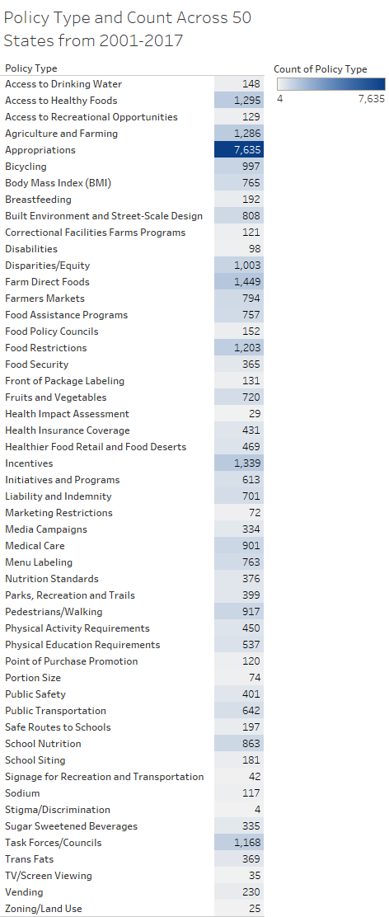

The first graph we’re going to look at is the spread of policies collected by the CDC and the number each type of policy has been enacted, introduced, vetoed or considered dead (Figure 1). Next, we will compare the statuses of all policies (Figure 2) and the distribution by state while also looking at the percentage of youth tobacco use in the same states. (Figure 3). The next graph (Figure 4) will consist of comparisons between middle school and high school students and percent of tobacco use for each school level. The fifth graph (Figure 5) will also look at tobacco percentages, however instead of looking at age in school it will compare male and female usage over the years. (Figure 6) will move on to the oral health of all students over the 2000-2020 period by specifically looking at the percentage of untreated tooth decay. The final figure will show the distribution of health topics over a similar time span (Figure #7).

Figure #1:(left) This table displays the total number of policies for each type of policy. These numbers include all policy statuses (enacted, vetoed, introduced, dead) and it’s the combined total over the time listed (2001-2017). Numbers are also the combined number of policies across all 50 U.S. states. The policy names provide a brief description of what the legislation/regulation is or was trying to provide, but it does not give full details. Policies were given dates enacted and dates effective, also not listed in table.

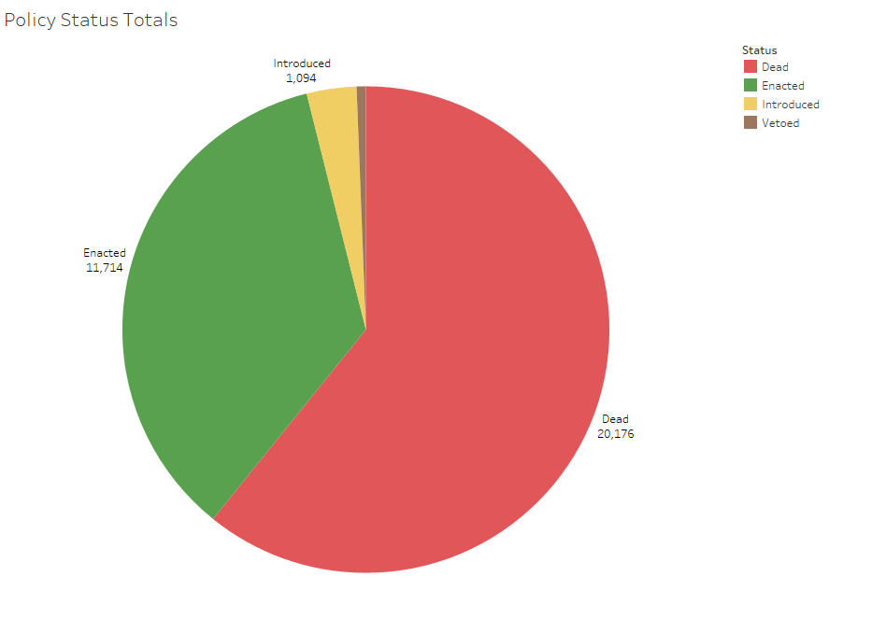

Figure #2: This is a pie chart that displays the ratio of policy statuses. There are two dominating statuses, dead and enacted, that take up the majority of the policy statuses. This shows that the majority of policies have either been enacted by the local or state government or they have since expired.

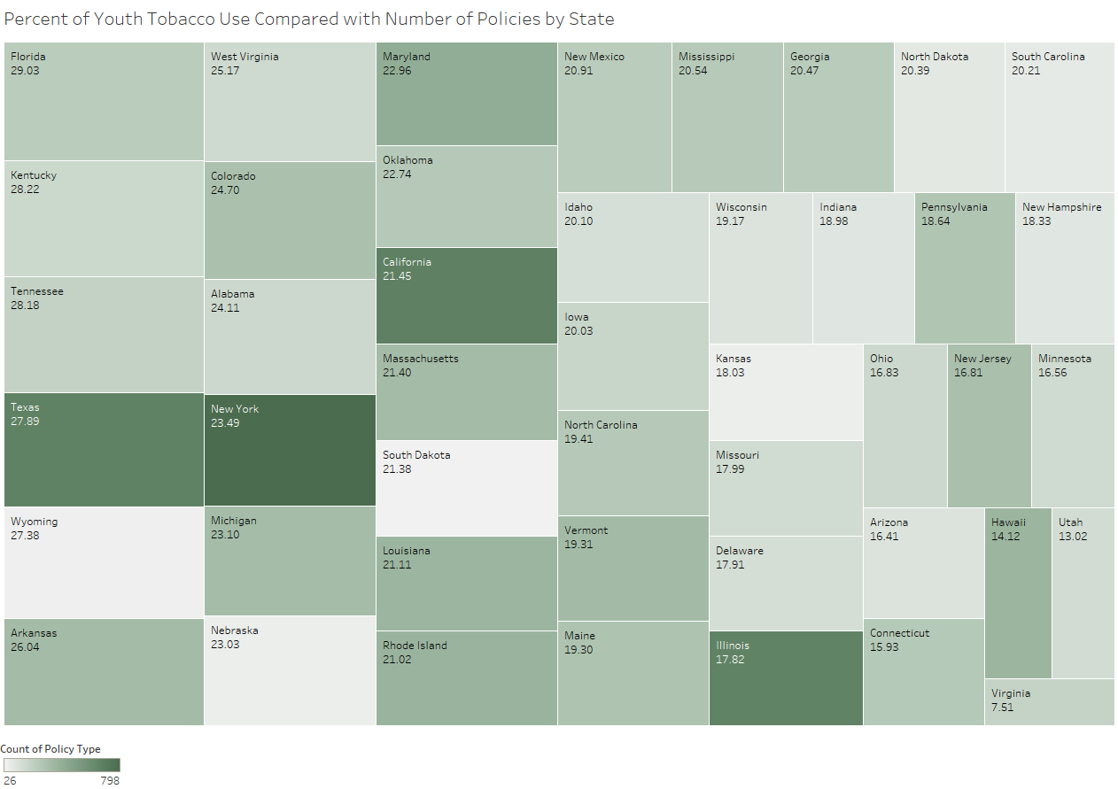

Figure #3: Tree map of states. Size of squares coincides with the number percentage listed in the square. Color of square coincides with the number of policies per state. This graph shows there is no correlation between the number of policies and percentage of youth tobacco use. States like Texas with high percentages also have high policy numbers whereas Kansas shows low percentage and low policy numbers. Illinois and Wyoming are examples of opposites as well, Wyoming with high percentage and low policy numbers and Illinois with low percentages and high policy numbers.

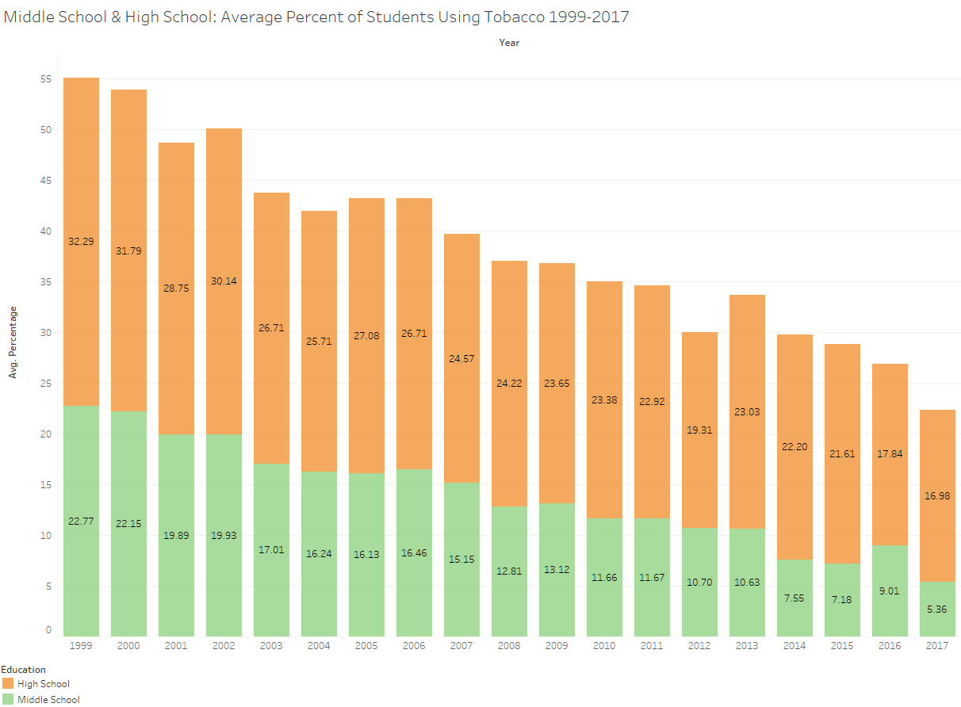

Figure #4: Stacked bar graph that splits percentage into two groups; Middle school on the bottom and High School on the top. The graph shows a steady decline in youth tobacco usage over the years of 1999-2017.

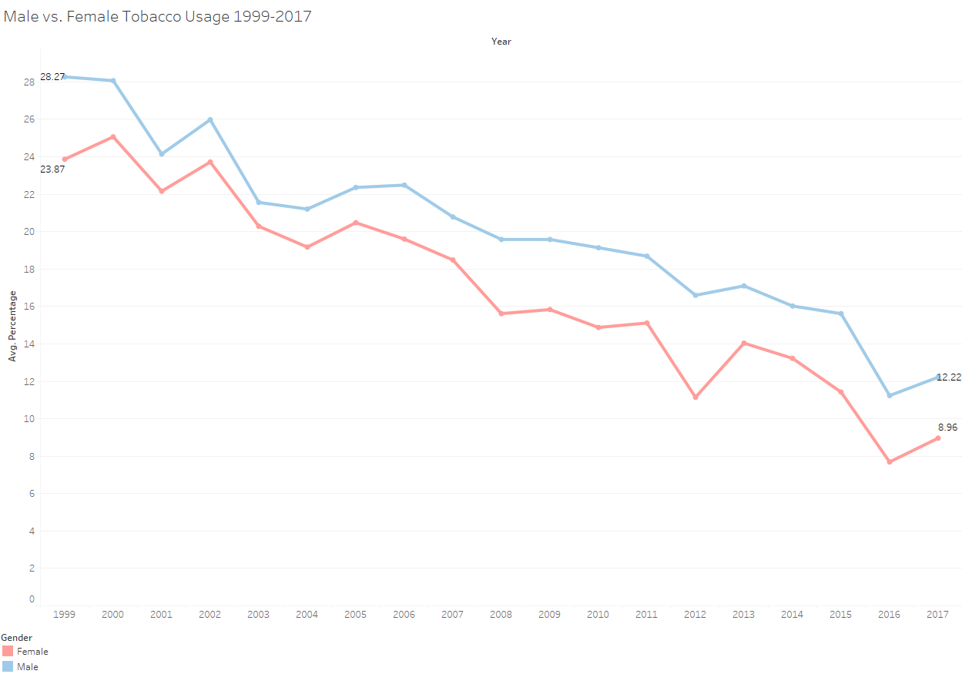

Figure #5: This line graph shows the difference between the two genders when it comes to youth tobacco usage. As can be seen from the graph, females always have a lower percentage than males, and both genders have seen a steady decrease in percent usage from 1999-2017.

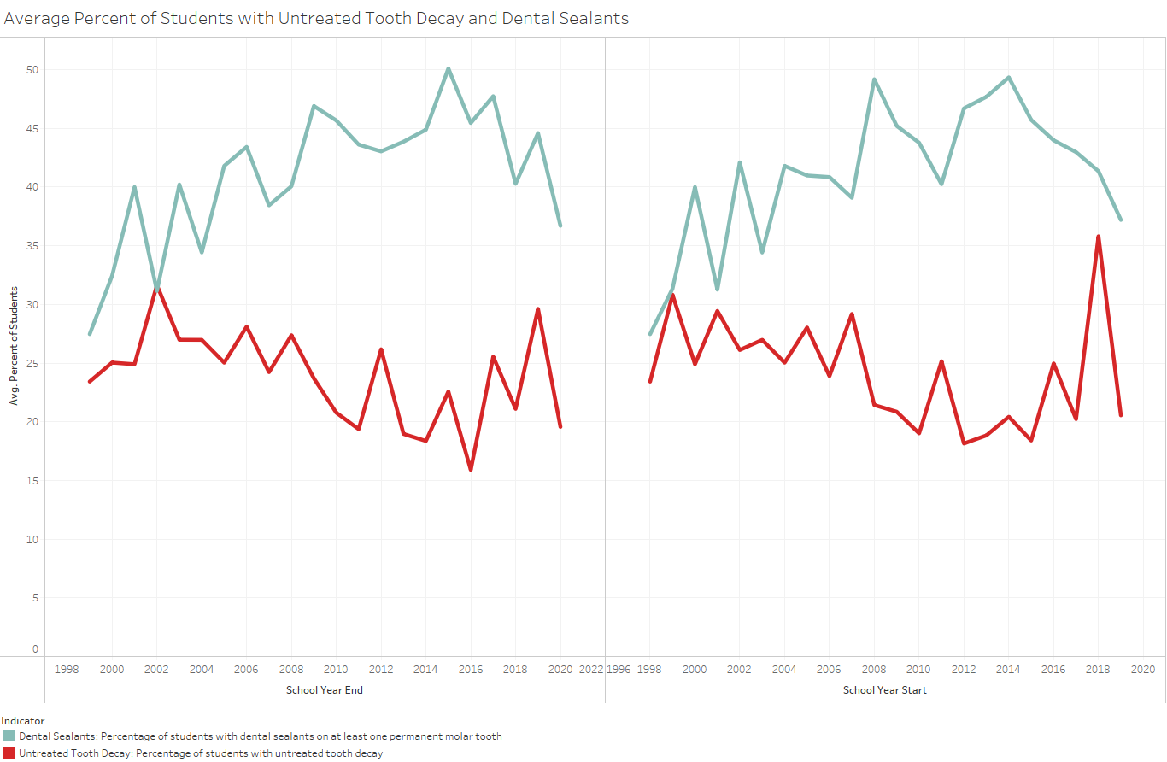

Figure #6: This figure covers two of the National Oral Health Survey indicators. One is the percent of students with dental sealants as the top line. The second, bottom line is the percent of students with varying levels of tooth decay. The graphs are split into two sections, School Year Start and School Year End. These are the percentages taken at the beginning of the school year and then at the end. For both indicators, the lines are very similar and show a sporadic increase and decrease in average percentage over the years.

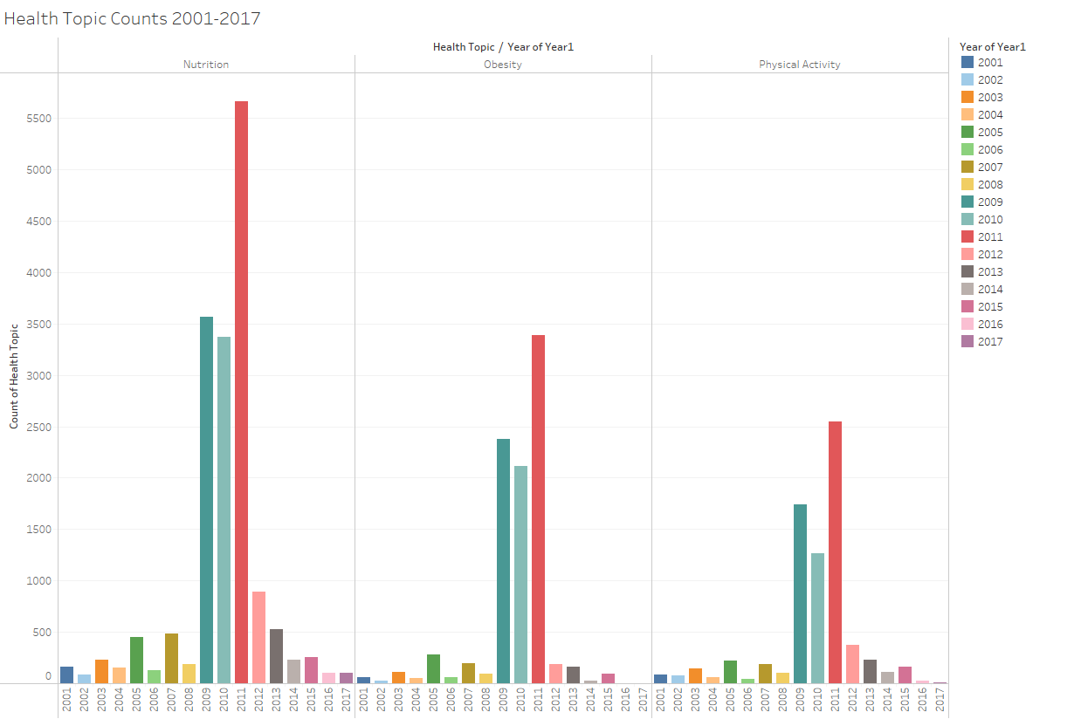

Figure #7: This figure splits the number of policies into three health topics, Nutrition, Obesity, and Physical Activity. It shows the number of policies per year, with all three topics showing a sharp increase from the years 2009-2011. The number of policies includes all status types, which the type of statuses can be references in Figure #2.

III. *Discussions*

A. *Initial Impressions*

Looking at the first figure, Figure #1, there is a large variety of legislation and/or regulations that have been written up across the United States. Each policy name gives a short description of what it was designed to help, for example, Access to Recreational Activities. This is a very straightforward name, the policy introduced and possibly enacted was designed to give the community better access to recreational activities. Other policy names, such as Appropriations, do not give a straightforward explanation. Instead, this policy calls for a search on the CDC website, which comes back with a process of gaining financial resources, which in many poor communities, would be very helpful. Figure #2 goes on to show the number of policies that made it through to be enacted into communities. From this graphic, it’s clear that many policies manage to be enacted, and at the time that the data set was last updated, nearly 12,000 policies were still in place.

Figure #3 starts to show a more interesting graph. This tree map combines two of the datasets to show how youth tobacco usage and policy count across the country compare with each other. The average percentage of tobacco usage ranges from 29% to 7.5% and the policy count per state ranges from 26 to 798. According to the CDC, teens are more likely to start using tobacco because of the results they believe they will have. These results are weight loss or coping with mental struggles more easily, and teens who struggle with mental health are more likely to use tobacco in general. Also teens who live in poorer communities are more vulnerable to starting tobacco. The policies being put in place by the CDC are said to focus on three things: Nutrition, Obesity, and Physical Activity. These three things all connect with being healthy, and seeing that these policies are put in place, it’s easy to assume that these policies should help teens to eat better and be more active to avoid gaining weight and help to fix mental health problems. Therefore, with these assumptions in place, it’s easy to think that the more policies put in place in a specific state would lower the percentage of youth tobacco usage. According to the graphic, this is not the case. If it was, all higher percentage states, such as Texas, Florida and Colorado would be much lighter in color, showing a low number of policies. Instead, there is no correlation with policy number and tobacco use percentage.

In Figure #4 and #5, both graphs show the percentage of tobacco use in four different categories. Figure #4 shows middle school and high school percentage and Figure #5 shows male and female percentage. In both graphs, there is a trend of a slow decrease from 1999 to 2017. Looking at the percentages, we can see that, overtime, using any form of tobacco has been decreasing and there might be some overarching fact that has caused this decrease. The policies of trying to improve nutrition, physical activity and obesity might show an effect on tobacco usage, however the next few graphics will not back up this point.

Figure #6 specifically looks at the third dataset by the CDC. It’s a National Oral Health Survey that targets kids in school. Oral health is specifically affected by food intake, and several of the programs, including the overarching health topic of Nutrition, mention healthier eating and helping communities to access better foods. This figure shows two lines, one line for dental sealants and the other shows untreated tooth decay in kids. Both lines have data that is collected at the beginning and the end of the school year. There is no visible difference from school year start to school year end, however throughout the years, the percentage of students with both dental sealants and tooth decay has no pattern. Similarly to the previous two graphics, the number of policies enacted around the country seemed to do little to influence students from having some kind of tooth decay problems. The final figure shows the last piece of information from the three datasets. This graph is a regular bar graph, showing the number of policies over 2001-2017. It shows a sharp increase in policy numbers around the years 2009-2011. Most of these numbers come from policies considered dead and policies that were enacted. These enacted policies should have a positive impact on the two data values, tobacco use and tooth decay in youths, however no such positive impact can be seen.

IV. *Conclusions*

One of the main conclusions that we can make from looking at this data is that the policies that have been developed to help communities aren’t reaching out far enough. Tobacco usage in the impressionable mind of a young teenager can be very dangerous, especially with the high chance of developing lung cancer from this use. The use of tobacco in general can lead to using and becoming addicted to other, more dangerous drugs in the future. The states that show more of these policies don’t show a decrease in tobacco use in comparison to other states with less policies. Overall, the use of tobacco in youths has been decreasing and will most likely continue to decrease as the years go on. We can attribute this to the widespread understanding of the harm that types of tobacco cause and this being taught to these same youths. This attribution is because tobacco use has slowly been declining since the beginning of when the data was collected, whereas if the policies were helping, we would see a sharp decline around the spike where many policies were enacted. We would also be able to see some sort of effect with the oral health survey and the percentage of children with tooth decay, but instead we hardly see any kind of pattern in that data.

Another conclusion to be made is that these policies are effective, but we just can’t see it. As mentioned in the first conclusion, the slow decline in tobacco use in youths is very evident over the 17-year time span. However, with these policies and regulations, it naturally takes a bit of time for there to be some sort of effect that happens after it is enacted. These policies could have a quick turn around, but giving them the benefit of the doubt means that there may be policies that were put into place before the CDC dataset. These older policies that we have no knowledge of within this assessment could have created the slow decrease of youth tobacco use. However, assuming that these policies were effective in helping curb tobacco use and tooth decay in youths, these policies would still be considered ineffective.

The last conclusion we can make is that these three individual features aren’t connected in any way. With the datasets, it wasn’t possible to see exactly where the policies and the surveys took place. According to the CDC, the policies were put into place in high-risk communities, where the residents were more prone to health issues and in lower income households. This is because these communities can lack the ability to lead healthier lives. The other two datasets were taken around the country and it is hard to determine if the communities this data was taken from were communities affected by the policies. If this is the case, we would need more data to see how the policies affect the communities that they impact, and we would need to look at other factors that have affected the lower rate of students using tobacco.

V. *Closing Statements*

As we’ve seen throughout this analysis, there is some good information and some bad information to take away from it. The good news is that the rate at which youths are participating in tobacco has been decreasing over the years, from around 30% in 2001 to 12% in 2017. This results in less teens influencing others, and less adults in the future suffering from harmful side effects of tobacco. However, the decrease in tobacco use is a good start, we should be aiming to decrease even more. If these policies have been a part of the decrease, we need to continue to enact them in communities. This way, youths will be deterred from trying and becoming addicted to any form of tobacco. The bad news from this analysis is that there are still too many youths that have to deal with bad oral health. Aside from the brain and the lungs which subconsciously keep us alive, our mouths are the next important part of our bodies. Keeping up with and teaching oral hygiene to young kids prevents them from having pain in the future. From looking at Figure #6, whether or not policies have been put in place to help fix oral health, oral health is not improving in youths. There has to be more that can be done to give youths access to hygiene products and knowledge to keep themselves from dealing with toothaches or other oral problems.

VI. *Applying Data Visualization from Class*

While working with these datasets, the goal I wanted to portray was showing trends and trying to prove or disprove my hypothesis. One thing I used a lot was the physical position of the data. In the bar graphs and line graphs, the bars or points that were towards the top of the graph always were higher values than those below. With this simple graph, showing trends of the number of users and how it decreased over time was very easy to do. That needed to be very apparent in Figure #4 & #5. Another map I felt was very useful to disprove the hypothesis was the one treemap. It helped to show one piece of data hierarchically using size, but because the color didn’t match up with the sizes at all, it was easy to show there was no relationship between those two sections of data. It was the major graphic, in my opinion, and it gave the most data in one single image. The pie chart was another useful tool because at first, the data that’s contained in that chart wasn’t something I was looking for. But thinking about all the sets as a whole, knowing the status of the policies is really important. The low number of vetoed policies shows that the policies are widely accepted and that there was more of a possibility that they influenced oral health and tobacco use.

*References*

DNPAO Public Inquiries. *CDC Nutrition, Physical Activity, and Obesity - Legislation,* United States of America:

Center for Disease Control and Prevention, 2021. Accessed on: Nov. 11, 2021. [Online].

Available: <https://catalog.data.gov/dataset/cdc-nutrition-physical-activity-and-obesity-legislation>

OHSData Support. *Youth Tobacco Survey (YTS) Data,* United States of America:Center for Disease Control and

Prevention, 2020. Accessed on Nov. 10, 2021.[Online].

Available: <https://catalog.data.gov/dataset/nohss-child-indicators-1cba3>

Oral Health Inquiries. *NOHSS Child Indicators,* United States of America:Center for Disease Control and

Prevention, 2021. Accessed on: Nov. 10, 2021. [Online].

Available: <https://catalog.data.gov/dataset/nohss-child-indicators-1cba3>

“CDC - Appropriations Process and Materials - Budgets, Grants, and Funding - STLT gateway,” *Centers for Disease*

*Control and Prevention*, Dec. 15, 2015. Accessed: Nov. 12, 2021. [Online]. Available:

<https://www.cdc.gov/publichealthgateway/grantsfunding/appropriations.html>

“Division of Nutrition, Physical Activity, Overweight and Obesity (DNPAO),” *Centers for Disease*

*Control and Prevention*, Aug. 23, 2021. Accessed: Nov. 12, 2021. [Online]. Available:

<https://www.cdc.gov/nccdphp/dnpao/index.html>

“Youth and Tobacco Use,” *Centers for Disease Control and Prevention*, Dec. 16, 2020. Accessed: Nov. 12, 2021.

[Online]. Available:

<https://www.cdc.gov/tobacco/data_statistics/fact_sheets/youth_data/tobacco_use/index.htm>